Low-Fidelity Prototype
Project Title: | Student Sentiment Analysis in social media: A Monitoring Tool for Student Satisfaction

Student Name | : | Lim Yong Kang
Matric Number | : | 279868
Supervisor | : | Dr Mohamad Sabri Bin Sinal@Zainal

INTRODUCTION
This project covers the low fidelity prototype of UUM Student Satisfaction Analysis Monitoring Tool interface.UUM Student Satisfaction Analysis Monitoring Tool is a monitoring tool that allows the management authority of each department in UUM to analyse the sentiment of Facebook posts or comments, whether it is positive or negative or neutral.

The function of this monitoring tool is to allow users to enter a Facebook post or comment, and it will calculate the accuracy of the sentiment of the sentence. Then, the accuracy of determining sentiment groups such as positive, negative, and neutral will be displayed as percentages. UUM Student Satisfaction Analysis Monitoring Tool will display the final sentiment result based on the accuracy of the sentiment groups. UUM Student Satisfaction Analysis Monitoring Tool will also show the details by highlighting the sentiment of each word in the input Facebook post or comment in a different colour.

This report includes two parts: designed interfaces with the functions and the demo low-fidelity prototype of the UUM Student Satisfaction Analysis Monitoring Tool.

INTERFACE

To conveniently build the low-fidelity prototype of the UUM Student Satisfaction Analysis Monitoring Tool, Figma has been used to sketch the interface.

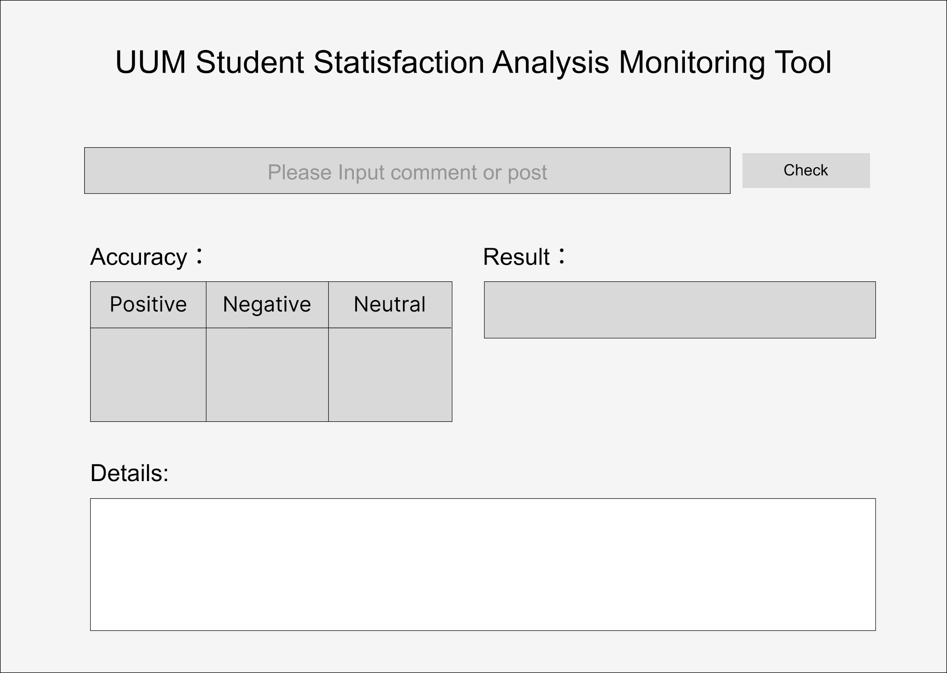

The figure shows the page of the UUM Student Satisfaction Analysis Monitoring Tool.

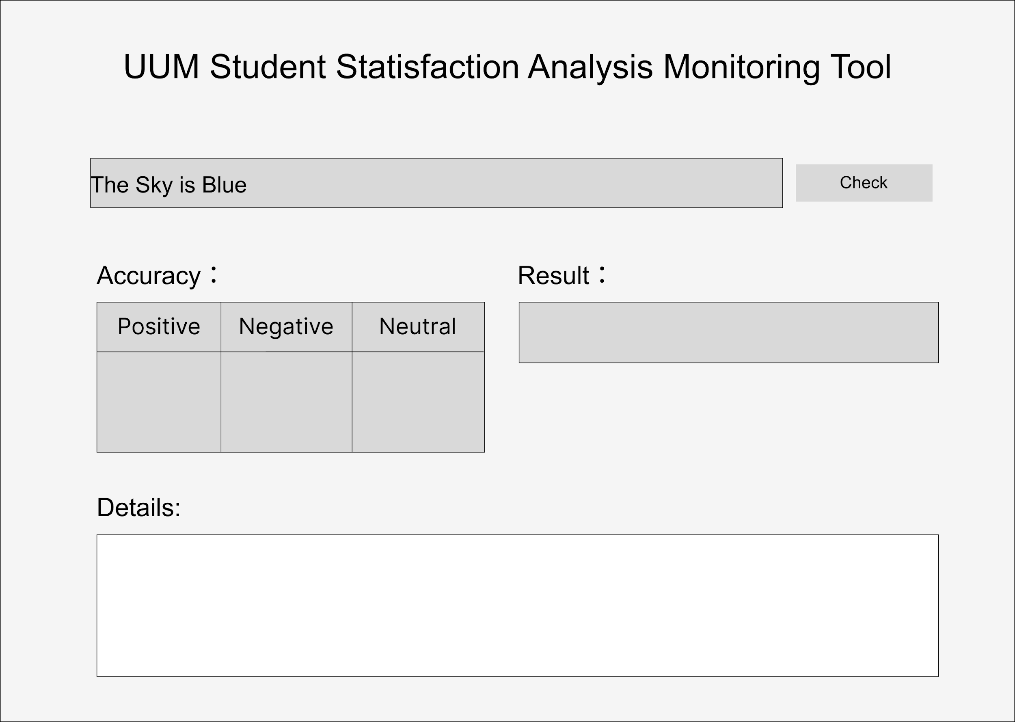

This figure shows the page allowing the user to input one Facebook post or comment simultaneously on the text box. After inputting the Facebook post and comment, the user can click the check button for analyse.

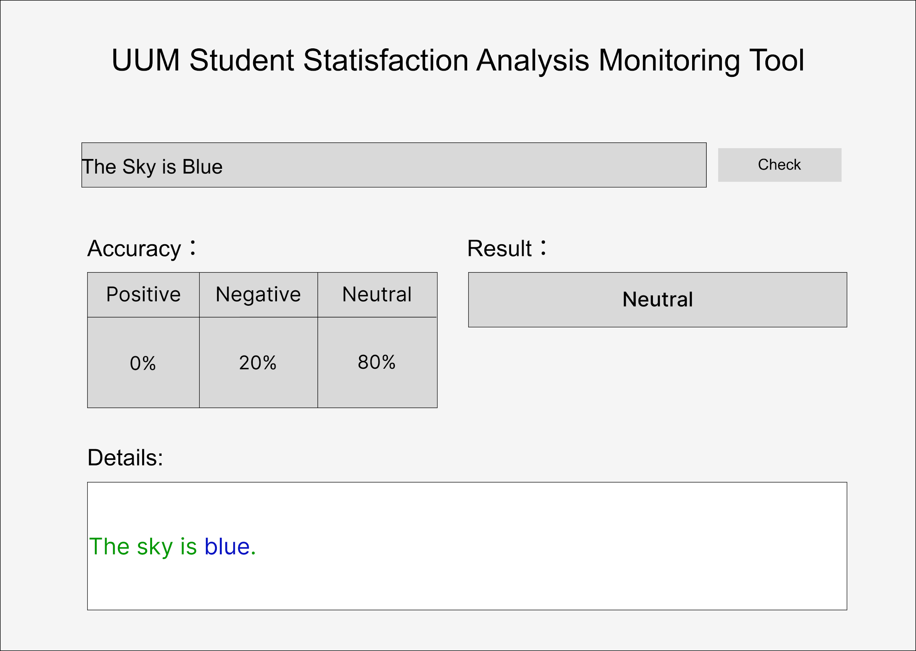

The figure displays the page where the input Facebook post or comment has been analysed, and the result, accuracy for each sentiment and the details are shown on each textbox. The accuracy will show the percentage of each sentiment for the Facebook post or comment. The result text box will show the sentiment based on the accuracy result. The details will show the sentences of the Facebook post or comment and highlight the word based on the sentiment; Dark blue stands for negative sentiment, Dark red is positive sentiment and Dark green frames for neutral.
DEMO OF LOW-FIDELITY PROTOTYPE
In this project, GUI or Graphical user interface in Java will be used to build the UUM Student Satisfaction Analysis Monitoring Tool interface.

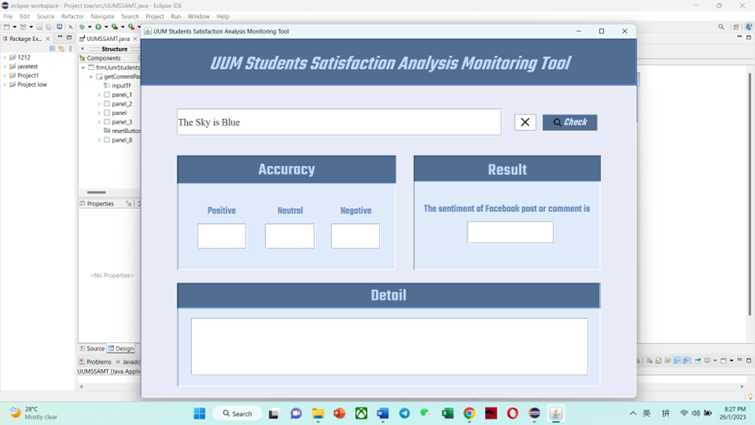

This figure shows that one Facebook post or comment has input in the text box.

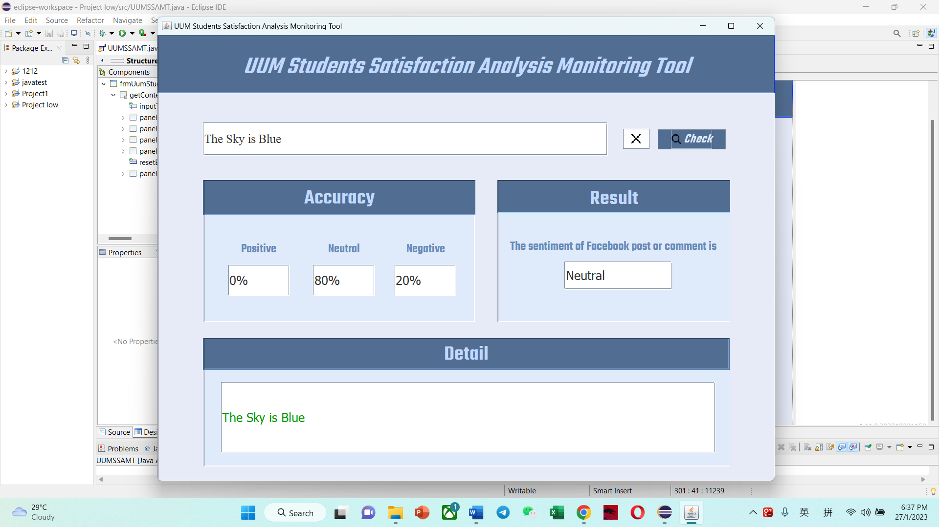

This figure shows the page displaying the accuracy, result, and details of the Facebook post or comment after clicking the check button.

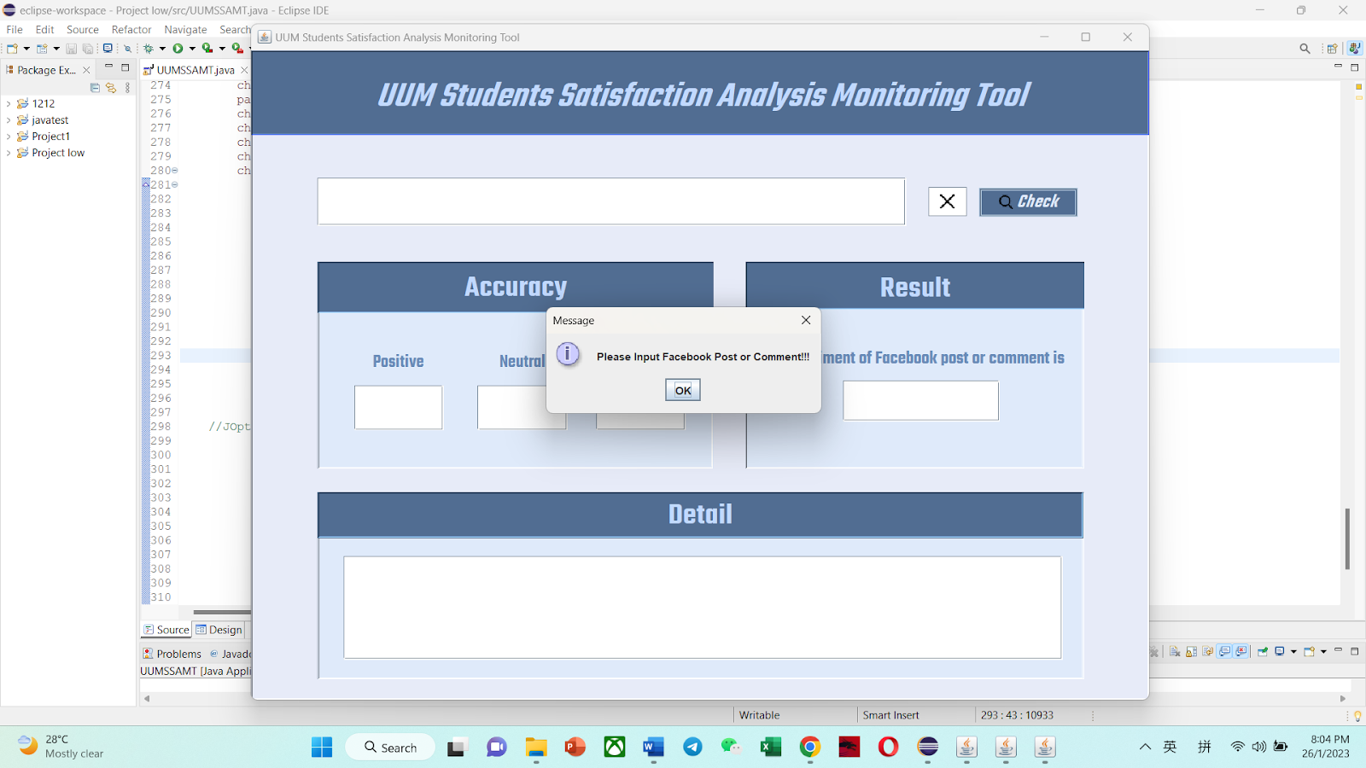

The figure displays the page that if the input text box is empty and clicking the check button, a message will pop out to remind the user to input the Facebook post and comment.

Declaration

I hereby declare that this submission is my own work and to the best of my knowledge it contains no materials previously published or written by another.

Student’s Signature |  | Date

Supervisor’s Approval

Project Supervisor’s Signature & Stamp |  | Date

Lecturer’s Approval

Approve without modification
Approve with modification
Reject

Remark:
___________________________________________________________________
___________________________________________________________________
___________________________________________________________________
___________________________________________________________________

Lecturer’s Signature & Stamp |  | Date

